Reference Videos

<https://www.youtube.com/watch?v=Ve9h7-E8EuM&t=203s>

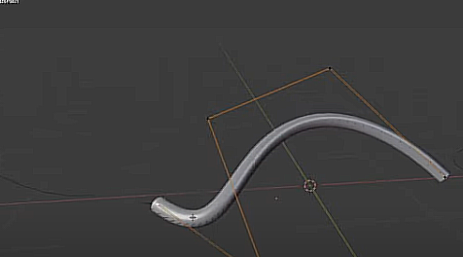

<https://www.youtube.com/watch?v=5BXvwqVyCQw>

